User Stories & Use Cases — AI-Powered Predictive Maintenance
Oct 2, 2026 · @Youssef

Overview
The system has 31 user stories and 21 use cases. Each one traces to a stakeholder (SH-ID) and a functional requirement (FR-ID), so they can go straight into the SRS.
- Sources: Stakeholder Analysis, AI/ML Functional Requirements (FR-AI-01 to 16), LLM/UI Functional Requirements (FR-UI-01 to 05, FR-LLM-01 to 04, FR-REP-01 to 03).
- Story format: As a <role>, I want <goal>, so that <benefit>.
- Priority: the same scale as the FRs: Critical, High, Medium.
- Gap: a story or use case with no matching FR yet. The Open Issues table lists them.

Actors
Eleven actors: eight human, three non-human. All human actors inherit from an abstract Authenticated User, so shared use cases (log in, dashboard) link once to the parent in the diagram.
Actor | Type | SH-ID | Main goal
Maintenance Technician | Primary, human | SH-01 | Act on alerts, find the cause, log repairs
Reliability Engineer | Primary, human | SH-02 | Analyse RUL and explanations, set thresholds, run what-if, make reports
Operator / Shift Supervisor | Primary, human | SH-03 | Watch machine status, acknowledge or escalate alerts
Maintenance Planner | Secondary, human | SH-04 | Schedule downtime and parts from RUL
Plant Manager | Secondary, human | SH-05 | Review fleet risk, KPIs and ROI
HSE Officer | Secondary, human | SH-07 | Get critical alerts fast, audit alert history
ML Engineer | Secondary, human | SH-08 | Train, compare, version and retrain models
System Admin | Secondary, human | SH-09 | Manage users, roles, API keys and LLM settings
Sensor Data Source | System | SH-10 | Push the replayed sensor stream (read-only)
LLM Service | External system | SH-12 | Answer assistant queries and write report narratives
Scheduler | Time | n/a | Trigger monthly reports and drift checks
The Planner is added to the actor list in Stakeholder Analysis section 7, since SH-04 needs its own view. Finance (SH-06) uses the system through the Plant Manager's ROI output, so it is not a separate actor.

User Stories
31 stories, ordered by actor. Each actor's SH-ID is in the Actors table.
ID | User story | Acceptance criteria | Priority | FRs
US-01 | As any user, I want to log in to a view built for my role. | Wrong password rejected; dashboard matches role; other pages blocked. | Critical | FR-UI-01, Gap
US-02 | As a technician, I want alerts showing machine, severity and likely cause, so I know what to check first. | Sorted Critical first; each shows machine, severity, time, top sensor. | Critical | FR-UI-05, FR-AI-07
US-03 | As a technician, I want to see why a machine was flagged, so I go straight to the fault. | SHAP/LIME chart of top sensors beside the prediction. | High | FR-AI-08, FR-UI-03
US-04 | As a technician, I want to ask the assistant about a machine in plain language. | Answer uses that machine's RUL, anomaly score and recent logs. | Critical | FR-LLM-01, 02
US-05 | As a technician, I want the assistant to work when the cloud LLM is down. | Timeout or privacy mode switches to the local model automatically. | Medium | FR-LLM-04
US-06 | As a technician, I want to log repairs, so history is complete and real failures feed retraining. | Saves machine, alert, date, action, parts; closes the alert. | High | Gap
US-07 | As an operator, I want each machine shown as Normal, Warning or Critical. | One colour-coded status per machine, matching the latest prediction. | High | FR-UI-01, FR-AI-07
US-08 | As an operator, I want status to update by itself when new data arrives. | New reading refreshes status with no reload. | Critical | FR-AI-04, FR-AI-10
US-09 | As an operator, I want to acknowledge an alert in one click. | New → Acknowledged; user and time saved. | Medium | FR-UI-05
US-10 | As an operator, I want to escalate an alert to an engineer or HSE. | Status Escalated; user and time saved; target notified. | Medium | FR-UI-05
US-11 | As a reliability engineer, I want RUL with a confidence range, so I can defend the forecast. | Value plus range, e.g. 18 days (14–23), with model version. | Critical | FR-AI-05, 06
US-12 | As a reliability engineer, I want sensor and RUL trend charts. | Vibration, temperature, pressure and RUL over a chosen range; zoom and hover. | Critical | FR-UI-02
US-13 | As a reliability engineer, I want what-if sliders that show the new RUL and severity. | Simulated results shown; live data, alerts and logs unchanged. | High | FR-UI-04
US-14 | As a reliability engineer, I want to set alert thresholds. | Authorised roles only; applies to next prediction; change logged. | High | FR-AI-09
US-15 | As a reliability engineer, I want a PDF report for a machine and date range. | Includes health, RUL, XAI, charts and an LLM summary. | High | FR-REP-01, 02
US-16 | As a reliability engineer, I want to mark false alarms, so the model improves. | Flag and reason saved and used in evaluation. | Medium | Gap
US-17 | As a reliability engineer, I want bad sensor records flagged before prediction. | Missing, wrong-type, out-of-range and bad-timestamp records kept out of inference. | High | FR-AI-01 to 03
US-18 | As a planner, I want machines sorted by lowest RUL, so I can plan downtime and parts. | Shows machine, RUL, range, severity; exportable. | High | FR-UI-01
US-19 | As a plant manager, I want a fleet overview with risk and downtime KPIs. | Count by severity, top at-risk machines, downtime KPIs. | High | FR-UI-01
US-20 | As a plant manager, I want a savings calculator, so I can prove ROI. | Editable costs; savings as a range with assumptions; can join the monthly report. | Medium | FR-REP-03
US-21 | As a plant manager, I want the monthly report generated automatically. | Scheduler creates the fleet PDF on the 1st of each month. | Medium | Gap
US-22 | As the HSE officer, I want to be notified the moment an alert turns Critical. | Every Critical alert notifies HSE with machine, cause and time. | High | Gap
US-23 | As the HSE officer, I want the full alert history for audits. | Includes closed alerts and every status change; filterable. | High | FR-UI-05 (partial)
US-24 | As the HSE officer, I want the assistant to refuse unsafe or off-topic requests. | Set refusal with a safety note. | High | FR-LLM-03
US-25 | As an ML engineer, I want to compare candidate models on the same metrics. | Precision, recall, F1, ROC-AUC, confusion matrix; MAE and RMSE for RUL. | Critical | FR-AI-11, 12
US-26 | As an ML engineer, I want every experiment and model version tracked. | MLflow logs version, type, parameters, dataset, metrics and date. | High | FR-AI-13
US-27 | As an ML engineer, I want each prediction logged with its model version. | Record holds machine, time, input ref, version, score, RUL, severity, XAI ref. | High | FR-AI-16
US-28 | As an ML engineer, I want drift warnings, so I retrain in time. | Significant drift raises a review flag. | Medium | FR-AI-14
US-29 | As an ML engineer, I want to retrain and keep the old version. | New version created; previous one kept. | Medium | FR-AI-15
US-30 | As an admin, I want to manage users and roles. | Add, edit, disable users; one role each. | High | Gap
US-31 | As an admin, I want secure API keys and a local-only mode. | Keys never shown in plain text; local-only keeps all LLM calls on site. | Medium | FR-LLM-04, Gap

Use Case List
21 use cases. UC-06 Run Inference is the shared core: the live stream and the what-if simulator both include it.
ID | Use case | Primary actor | Secondary actors | Relationship | FRs
UC-01 | Log In | Authenticated User |  |  | Gap
UC-02 | View Fleet Dashboard | Authenticated User |  |  | FR-UI-01
UC-03 | View Machine Details | Technician, Reliability Engineer, Operator |  | Extended by UC-04 | FR-UI-02
UC-04 | View Prediction Explanation | Technician, Reliability Engineer |  | «extend» UC-03 | FR-AI-08, FR-UI-03
UC-05 | Ingest Sensor Data | Sensor Data Source |  | «include» UC-06 | FR-AI-01, 02, 03
UC-06 | Run Inference | (included only) |  | Included by UC-05, UC-11 | FR-AI-04 to 08, FR-AI-10, FR-AI-16
UC-07 | Raise Alert | (system) | Operator, HSE Officer | «extend» UC-06 when severity is Warning or Critical | FR-AI-07, Gap (notification)
UC-08 | Acknowledge / Escalate Alert | Operator | Technician |  | FR-UI-05
UC-09 | Log Maintenance Action | Technician |  |  | Gap
UC-10 | Ask Maintenance Assistant | Technician, Reliability Engineer | LLM Service |  | FR-LLM-01 to 04
UC-11 | Run What-If Simulation | Reliability Engineer |  | «include» UC-06 | FR-UI-04
UC-12 | Configure Thresholds | Reliability Engineer |  |  | FR-AI-09
UC-13 | Generate Diagnostic Report | Reliability Engineer, Plant Manager, Scheduler | LLM Service |  | FR-REP-01, FR-REP-02
UC-14 | Calculate ROI | Plant Manager |  |  | FR-REP-03
UC-15 | Review Alert History | HSE Officer | Reliability Engineer | Extended by UC-16 | FR-UI-05 (partial)
UC-16 | Flag False Alarm | Reliability Engineer |  | «extend» UC-15 | Gap
UC-17 | Train and Compare Models | ML Engineer |  | Included by UC-19 | FR-AI-11, 12, 13
UC-18 | Monitor Data Drift | Scheduler | ML Engineer |  | FR-AI-14
UC-19 | Retrain and Deploy Model | ML Engineer |  | «include» UC-17 | FR-AI-13, FR-AI-15
UC-20 | Manage Users and Roles | System Admin |  |  | Gap
UC-21 | Configure LLM Settings | System Admin | LLM Service |  | FR-LLM-04
Include vs extend: «include» always runs (ingesting data always runs inference). «extend» runs only on a condition (an alert is raised only when severity reaches Warning).

Use Case Diagram
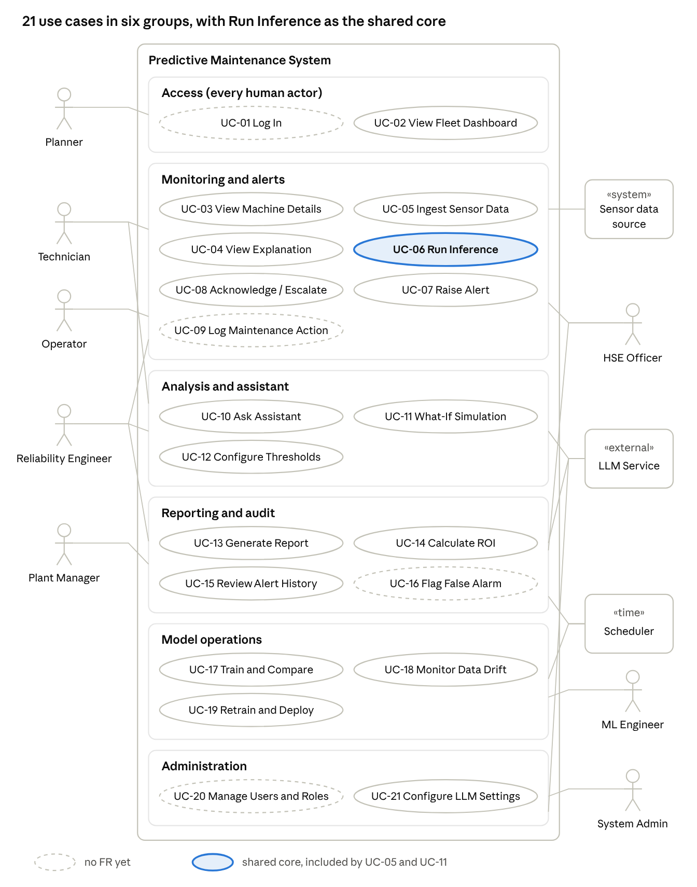
use case overview · 11 actors, 21 use cases in 6 groups
Lines show which actors use each group. The exact actor-to-use-case links and the «include» / «extend» relations are in the Use Case List; use them when you redraw this in your UML tool with one line per association.

Detailed Use Cases
All 21 use cases in ID order. Pre = precondition, Post = postcondition. FRs for each are in the Use Case List.

UC-01 Log In
Actor: Authenticated User · Pre: account created by admin · Post: role dashboard open, attempt logged
- User enters username and password.
- System checks them, loads the role and opens UC-02.
Alternates: 2a Wrong credentials → error, retry · 2b Account disabled → access denied

UC-02 View Fleet Dashboard
Actor: Authenticated User · Pre: logged in · Post: read only
- System loads the latest severity for every machine.
- System shows the role's view: status per machine (Normal / Warning / Critical), active alerts, lowest-RUL machines.
- User selects a machine (UC-03).
Alternates: 1a No predictions yet → "No data" · 2a Plant Manager → fleet KPIs added · 2b Planner → sorted by lowest RUL, with export

UC-03 View Machine Details
Actor: Technician, Reliability Engineer, Operator · Pre: logged in, machine has data · Post: read only
- System shows status, anomaly score, RUL with range and model version.
- System plots vibration, temperature, pressure and the RUL trend.
- User changes the date range and the charts update.
Alternates: 2a No data in range → message · 3a User asks why → UC-04

UC-04 View Prediction Explanation (extends UC-03)
Actor: Technician, Reliability Engineer · Pre: UC-03 open · Post: read only
- User clicks "Why?" on a prediction.
- System shows a SHAP/LIME chart of the top contributing sensors and a one-line summary.
Alternates: 2a Explanation missing → message, prediction still shown

UC-05 Ingest Sensor Data (includes UC-06)
Actor: Sensor Data Source · Pre: model deployed, thresholds set · Post: prediction stored, dashboard updated
- Source sends vibration, temperature, pressure, timestamp and machine ID.
- System validates fields, types, ranges and timestamp order.
- System preprocesses the data (missing values, normalisation, windowing, FFT) and extracts features.
- System runs UC-06 and updates the dashboard.
Alternates: 2a Invalid record → flagged, logged, skipped

UC-06 Run Inference (included by UC-05, UC-11)
Actor: none (included) · Pre: preprocessed data, model deployed · Post: result returned, logged in live mode
- FastAPI receives the features and the mode (live or sandbox).
- Models return anomaly score, status, RUL and range.
- System sets severity from the thresholds and adds the SHAP/LIME explanation.
- System returns the result with the model version and, in live mode, logs it.
Alternates: 2a Model error → error returned, last valid status kept · 3a Live and Warning/Critical → UC-07 · 4a Sandbox → no log, no alert

UC-07 Raise Alert (extends UC-06)
Actor: System · Secondary: Operator, HSE Officer · Pre: live severity is Warning or Critical · Post: alert stored as New
- System creates an alert with machine, severity, top cause and time.
- The alert appears in the alert table and on the dashboard.
Alternates: 1a Open alert already exists → updated, not duplicated · 2a Critical → HSE Officer notified at once

UC-08 Acknowledge / Escalate Alert
Actor: Operator · Secondary: Technician · Pre: alert is New · Post: status, user and time saved
- Operator opens the alert table (sorted by severity) and selects an alert.
- Operator clicks Acknowledge.
- System sets the status to Acknowledged.
Alternates: 2a Escalate → status Escalated, Reliability Engineer notified (plus HSE Officer if Critical) · 2b Already acknowledged → shows who, duplicate blocked

UC-09 Log Maintenance Action
Actor: Technician · Pre: logged in · Post: record saved, linked alert closed
- Technician clicks Log Repair on an alert or machine.
- Technician enters date, action, parts and notes.
- System saves the record, links it to the alert and closes the alert.
Alternates: 1a Planned work, no alert → saved against the machine · 3a Missing field → highlighted, not saved

UC-10 Ask Maintenance Assistant
Actor: Technician, Reliability Engineer · Secondary: LLM Service · Pre: machine selected · Post: answer shown and logged
- User asks a question about the selected machine.
- System checks the question is in scope.
- System adds the machine's RUL, anomaly score and recent logs to the prompt.
- LLM Service answers and System shows it.
Alternates: 2a Unsafe or off-topic → set refusal with safety note · 4a Cloud API down or privacy mode → local model answers

UC-11 Run What-If Simulation (includes UC-06)
Actor: Reliability Engineer · Pre: machine has current data · Post: live data, alerts and logs unchanged
- Engineer opens the simulator; sliders load the current readings.
- Engineer moves the sliders.
- System runs UC-06 in sandbox mode and shows the simulated RUL, range and severity beside the live values.
Alternates: 2a Value outside physical range → blocked · 2b Reset → live readings restored

UC-12 Configure Thresholds
Actor: Reliability Engineer · Pre: role allowed · Post: applied to next prediction, change logged
- Engineer opens Thresholds; System shows anomaly, RUL, critical and sensor-limit values.
- Engineer edits and saves.
- System checks the values, saves them and logs user, old and new values. No retraining needed.
Alternates: 1a Role not allowed → page blocked · 3a Conflicting values (Warning RUL below Critical) → rejected with reason

UC-13 Generate Diagnostic Report
Actor: Reliability Engineer, Plant Manager, Scheduler · Secondary: LLM Service · Pre: predictions in range · Post: PDF ready
- User picks a machine and date range and clicks Generate Report.
- System gathers health, RUL, XAI factors and charts.
- LLM Service writes a short narrative with recommendations.
- System builds the PDF for download.
Alternates: 1a Scheduler (monthly) → fleet report stored for the Plant Manager · 2a No data → message, stop · 3a LLM down → local model; if that fails, PDF without narrative

UC-14 Calculate ROI
Actor: Plant Manager · Pre: prediction and alert history exists · Post: result can join the monthly report
- Plant Manager opens the ROI tab and enters downtime cost per hour and repair costs.
- System shows savings vs reactive maintenance as a range, with assumptions.
- Plant Manager clicks Add to Report.
Alternates: 1a Empty or negative value → error

UC-15 Review Alert History
Actor: HSE Officer · Secondary: Reliability Engineer · Pre: logged in · Post: read only
- User opens Alert History, including closed alerts.
- User filters by machine, severity and date.
- User opens an alert to see each status change with user and time, and exports the list.
Alternates: 3a Alert was false → UC-16

UC-16 Flag False Alarm (extends UC-15)
Actor: Reliability Engineer · Pre: alert acknowledged or closed · Post: flag used in next evaluation
- Engineer clicks Flag as False Alarm and enters a reason.
- System saves flag, reason, user and time and adds the alert to the feedback set.
Alternates: 1a Already flagged → shows who and when, can unflag with a reason

UC-17 Train and Compare Models (included by UC-19)
Actor: ML Engineer · Pre: datasets ready · Post: runs in MLflow, chosen model registered
- ML Engineer picks candidates (Random Forest, XGBoost, LightGBM, LSTM, GRU, 1D-CNN, Autoencoder).
- System trains each and logs parameters and dataset version.
- System shows metrics side by side: precision, recall, F1, ROC-AUC, confusion matrix; MAE and RMSE for RUL.
- ML Engineer registers the best one as a new version.
Alternates: 2a A run fails → logged, others continue · 4a None good enough → nothing registered

UC-18 Monitor Data Drift
Actor: Scheduler · Secondary: ML Engineer · Pre: reference data stored · Post: drift status saved
- Scheduler triggers the check.
- System compares recent sensor data with the training distribution and saves the status.
Alternates: 2a Significant drift → flag raised, ML Engineer notified (may start UC-19)

UC-19 Retrain and Deploy Model (includes UC-17)
Actor: ML Engineer · Pre: updated dataset available · Post: new version tracked, old one kept
- A drift flag, accuracy drop or new failure data triggers retraining.
- ML Engineer runs UC-17 on the updated data.
- System deploys the chosen version to FastAPI.
Alternates: 2a Nothing beats the current model → no deploy · 3a New version misbehaves → roll back

UC-20 Manage Users and Roles
Actor: System Admin · Pre: logged in · Post: applies at next login, change logged
- Admin opens User Management and adds a user with name, email and role.
- System checks the details, saves and logs the change.
Alternates: 1a Change a role or disable a user (disabled users can't log in) · 2a Email exists → error

UC-21 Configure LLM Settings
Actor: System Admin · Secondary: LLM Service · Pre: logged in · Post: key stored encrypted
- Admin opens LLM Settings (provider, masked key, mode).
- Admin enters a new key or picks a mode: cloud with local fallback, or local only.
- System tests the connection and saves.
Alternates: 2a Local only → all LLM requests stay on site · 3a Test fails → old key kept

Traceability and Open Issues
Every existing FR is covered by at least one story and one use case. Eight stakeholder needs have no FR yet. They are listed below as Open Issues, to be added before the final SRS.

FR to story to use case
FR | User stories | Use cases
FR-AI-01, 02, 03 | US-17 | UC-05
FR-AI-04 | US-08 | UC-06
FR-AI-05, 06 | US-11 | UC-03, UC-06
FR-AI-07 | US-02, US-07 | UC-06, UC-07
FR-AI-08 | US-03 | UC-04, UC-06
FR-AI-09 | US-14 | UC-12
FR-AI-10 | US-08 | UC-06, UC-11
FR-AI-11, 12 | US-25 | UC-17
FR-AI-13 | US-26 | UC-17, UC-19
FR-AI-14 | US-28 | UC-18
FR-AI-15 | US-29 | UC-19
FR-AI-16 | US-27 | UC-06
FR-UI-01 | US-01, US-07, US-18, US-19 | UC-02
FR-UI-02 | US-12 | UC-03
FR-UI-03 | US-03 | UC-04
FR-UI-04 | US-13 | UC-11
FR-UI-05 | US-02, US-09, US-10, US-23 | UC-08, UC-15
FR-LLM-01, 02 | US-04 | UC-10
FR-LLM-03 | US-24 | UC-10
FR-LLM-04 | US-05, US-31 | UC-10, UC-21
FR-REP-01, 02 | US-15 | UC-13
FR-REP-03 | US-20 | UC-14

Open Issues
Missing FR | Comes from | Stories | Use cases
Login and role-based access | Stakeholder Analysis §7 (role-based login) | US-01 | UC-01
User and role management | SH-09 IT Admin | US-30 | UC-20
Maintenance action logging | SH-01 role (logs repairs) | US-06 | UC-09
Critical alert notification | SH-07 HSE need | US-22 | UC-07
Scheduled monthly report | SH-05 need (monthly PDF) | US-21 | UC-13
False-alarm feedback | §6 conflict resolution | US-16 | UC-16
Full alert history and audit trail (extend FR-UI-05) | SH-07 audits | US-23 | UC-15
Secure API key storage | SH-09 IT Admin | US-31 | UC-21
Severity labels: this document uses Normal / Warning / Critical. FR-AI-07 still says Info / Warning / Critical and should be updated to match.

